**ROLL NO. 2625489**

Ans1. a) Retrieve data for age>30

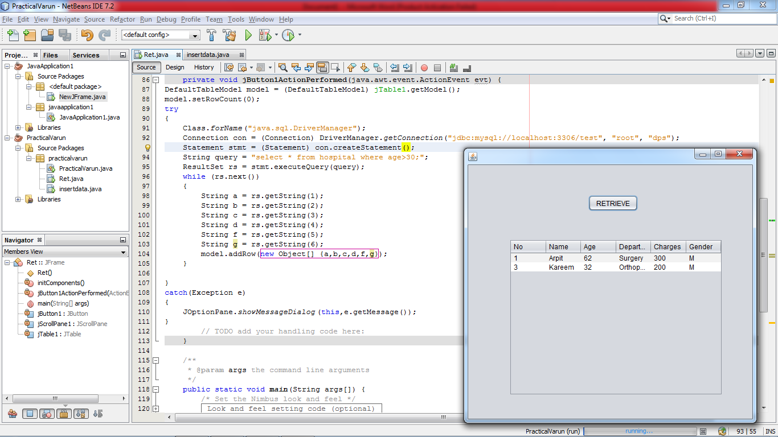

package practicalvarun;

import com.mysql.jdbc.Connection;

import java.sql.DriverManager;

import java.sql.ResultSet;

import java.sql.Statement;

import javax.swing.JOptionPane;

import javax.swing.table.DefaultTableModel;

public class Ret extends javax.swing.JFrame {

public Ret() {

initComponents();

}

private void jButton1ActionPerformed(java.awt.event.ActionEvent evt) {

DefaultTableModel model = (DefaultTableModel) jTable1.getModel();

model.setRowCount(0);

try

{

Class.forName("java.sql.DriverManager");

Connection con = (Connection) DriverManager.getConnection("jdbc:mysql://localhost:3306/test", "root", "dps");

Statement stmt = (Statement) con.createStatement();

String query = "select * from hospital where age>30;";

ResultSet rs = stmt.executeQuery(query);

while (rs.next())

{

String a = rs.getString(1);

String b = rs.getString(2);

String c = rs.getString(3);

String d = rs.getString(4);

String f = rs.getString(5);

String g = rs.getString(6);

model.addRow(new Object[] {a,b,c,d,f,g});

}

}

catch(Exception e)

{

JOptionPane.showMessageDialog(this,e.getMessage());

}

}

b) Insert record

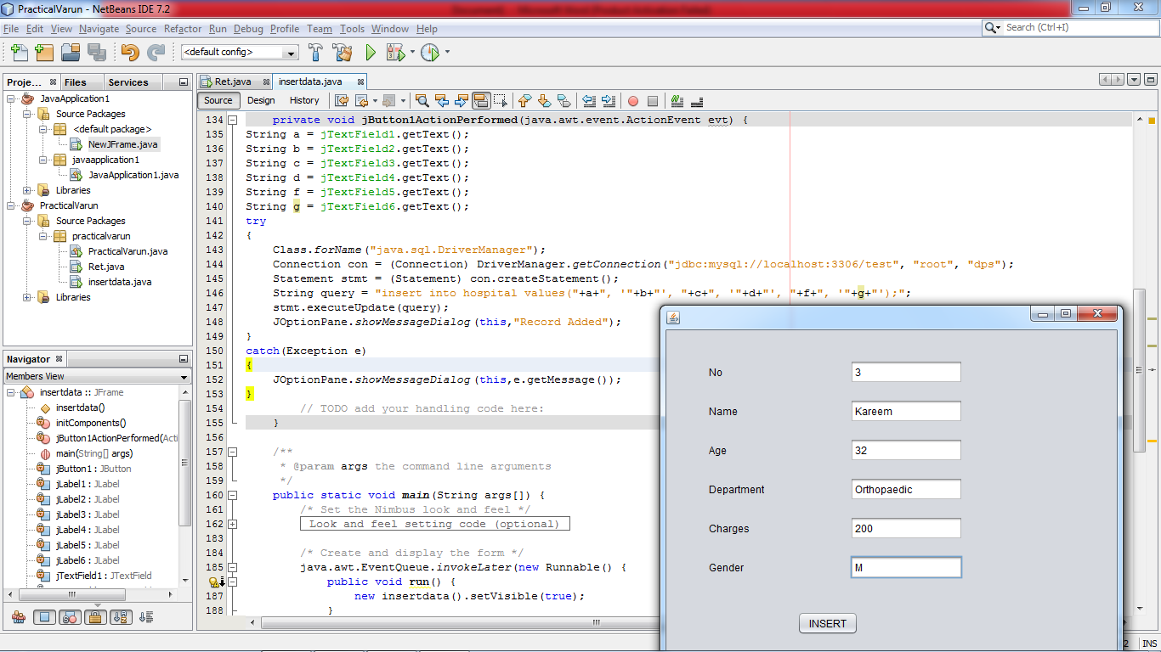

package practicalvarun;

import com.mysql.jdbc.Connection;

import java.sql.DriverManager;

import java.sql.Statement;

import javax.swing.JOptionPane;

public class insertdata extends javax.swing.JFrame {

public insertdata() {

initComponents();

}

private void jButton1ActionPerformed(java.awt.event.ActionEvent evt) {

String a = jTextField1.getText();

String b = jTextField2.getText();

String c = jTextField3.getText();

String d = jTextField4.getText();

String f = jTextField5.getText();

String g = jTextField6.getText();

try

{

Class.forName("java.sql.DriverManager");

Connection con = (Connection) DriverManager.getConnection("jdbc:mysql://localhost:3306/test", "root", "dps");

Statement stmt = (Statement) con.createStatement();

String query = "insert into hospital values("+a+", '"+b+"', "+c+", '"+d+"', "+f+", '"+g+"');";

stmt.executeUpdate(query);

JOptionPane.showMessageDialog(this,"Record Added");

}

catch(Exception e)

{

JOptionPane.showMessageDialog(this,e.getMessage());

}

}